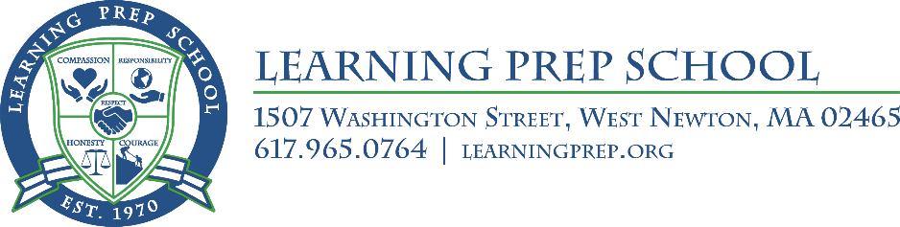

Protocols of the Learning Prep School
Partners in Education

Purpose
- The name of the Association shall be the Learning Prep School (LPS) Partners In Education (PIE).
- The intent of the Association shall be to cultivate and nurture a strong sense of community, to advance good will, to facilitate the exchange of information and ideas between the school and parents, to promote and enhance the character, culture, and values of the educational program, and to support LPS in its mission to foster an understanding of language-based learning disabilities by:

- Maintaining, developing, and extending relationships between parents, staff, administration, and others associated with the School;
- Working in concert with LPS organizing activities which support and advance the education of the students attending the School;
- Examples include, but are not limited to the following:
- Provide educational enrichment workshops for parents
- Provide staff appreciation events
- Supporting Senior Week activities
- Supporting Parent social events such as coffees with the LPS Executive Director, Chief Operating Officer & other administrators and staff; potluck suppers, et al
- Volunteering
- Sponsoring various family events/outings
- Support LPS Blue/Green Spirit Program activities
- Raising and dispensing funds and/or resources to assist projects not usually provided by the School, in order to enhance the well-being of and provide benefit to its students and to support charitable causes.
- Serving in a constructive way to share parent ideas, concerns, and questions with LPS and assisting the school when and where appropriate on such matters.
- The Partners in Education Executive Committee will also serve in that capacity for the Parent Advisory Group (PAG). In essence, it is forum for an exchange of ideas. The PAG shall advise the school on education, health, and safety of students. LPS encourages constructive engagement from the PAG with respect to these aspects of the educational program. Commencing with school year 2018-19 the PAG will host four meetings each school year open to all LPS parents and staff, focusing on the accomplishments, the challenges, and the opportunities attendant to the present and future of LPS. In essence, it is a salient and timely focus on the “State of the School.” The Parent Advisory Group meetings with parents will be held in October, December, February, and April. The Massachusetts Department of Elementary and Secondary Education (DESE) requires that each 766 school establish a PAG.
- PIE is a non-profit organization. No part of earnings or surplus should be for the private benefit of any individual.
Membership
- Membership shall consist of all parents and/or guardians of students enrolled at the School. In addition, teachers and administrators are considered members of PIE.
- Membership shall cease when a student leaves the School or a Teacher/Administrator is no longer attached to the School.
Leadership
- Partners In Education is led by an Executive Committee consisting of five parents, elected by the parent body, and five LPS administrators. The five parents represent the parent body as follows: (2) middle school (grades 5-8); (2) high school (grades 9-12); and (1) at-large member (grades 5-12). The five LPS administrators include the Executive Director, the Chief Financial Officer, the Chief Operating Officer, the Middle School Principal, and the High School Principal.
- The five parent members of the Executive Committee of PIE will be elected for a two-year term by the parent body of the grade levels that they represent. Parent members of the Executive Committee may serve no more than two consecutive terms.
- The PIE Executive Committee may establish subcommittees of PIE which may include a Nominating Committee and an Events Committee. Each subcommittee will have a Chair appointed by the PIE Executive Committee.
- Any items that require a vote must receive a 2/3rds (70%) vote of the Executive Committee for said item to be approved.
- Parent candidates for the positions on the Executive Committee must submit in writing a letter declaring their candidacy for the Executive Committee by a date determined by the Executive Committee. The election will be held on a date determined by the Executive Committee with ballots sent electronically to the general membership. Completed ballots must be submitted by a date determined by the Executive Committee.
- PIE elections are held every two years unless a position becomes vacant, at which point the Nominating Committee will declare the vacancy and develop a timeline and guideline to fill said position.
- A simple majority will determine the winner of any and all PIE elections for office.
Meetings
- PIE Executive Committee meetings will be held five times each year during the months of September, November, January, March, and May. Any PIE member may attend these meetings. Unless otherwise noted, the meetings will be held at LPS from 8:30-9:30am on the third Thursday of the month. Parents and LPS staff are most welcome to attend these meetings.
- The Executive Committee agenda will include topics that may be of interest to the general school community. Individual school personnel and individual students may not be placed on an agenda or be discussed at a meeting of the Executive Committee. Members of the Executive Committee, on behalf of themselves or their respective constituents, may send items that they would like to be considered for placement on a future agenda c/o the Administrative Assistant to the Executive Director, no later than ten (10) school days prior to the next meeting of the Executive Committee.
Code of Conduct
- LPS and PIE share the belief that a relationship based on mutual respect, relational trust, civility, and honesty will serve as the cornerstones of this organization. It is expected that all members of the organization will conduct themselves in this manner.
- All LPS community members, students, staff, parents, and others are expected to reflect these standards of behavior on campus, as well as at school sponsored events and activities, and in their respective use and application through social media and other forms and venues for communication.
- Directing comments and questions to the appropriate individual(s) and at the appropriate time and appropriate venue is critical to forging a culture of respect.

- Actions, words (written or spoken), or incidents that compromise the standards of the Code of Conduct will be resolved cooperatively between or among the individual(s) most directly involved and any other appropriate parties at a designated date, time, and place. Failure to do so may result in the termination of PIE membership by the offending parties.

Established March 7, 2018

